**LAB 12C – LAB EXERCISE**

**Relational database**

Activity description: Create a database for a university to manage students, courses, and

enrollments, and practice performing some SQL queries.

Assignment:

• Create three tables:

o ‘students’ table with columns:

▪ id, serial and primary key

▪ name, variant character maximum of 100 characters

▪ major, variant character maximum of 100 characters

-- Creating the 'student' table

CREATE TABLE student (

id SERIAL PRIMARY KEY,

name VARCHAR(100),

major VARCHAR(100)

);

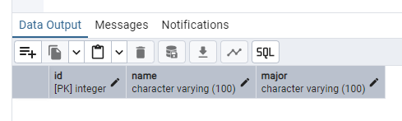

o ‘courses’ table with columns:

▪ id, serial and primary key

▪ title, variant character maximum of 100 characters.

▪ department, variant character maximum of 100 characters.

-- Creating the 'courses' table

CREATE TABLE course (

id SERIAL PRIMARY KEY,

title VARCHAR(100),

department VARCHAR(100)

);

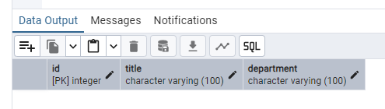

o ‘enrollments’ table with columns:

▪ id, serial and primary key

▪ grade, 2 characters

▪ Foreign key named ‘student_id’ to student’s id

▪ foreign key named ‘courses_id' to courses’ id

-- Creating the 'enrollments' table

CREATE TABLE enrollments (

id SERIAL PRIMARY KEY,

grade CHAR(2),

student_id INTEGER REFERENCES students(id),

course_id INTEGER REFERENCES courses(id)

);

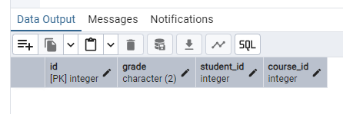

• Data entry for each table:

o Four students:

▪ name: ‘Alice Brown’, Major: Computer Science

▪ name: ‘Peter Pan’, Major: Mathematics

▪ name: 'Annie Chen’, major: Physics

▪ name: ‘your name’, major: Mathematics

-- Inserting data into the 'students' table INSERT INTO students (name, major) VALUES ('Alice Brown', 'Computer Science'), ('Peter Pan', 'Mathematics'), ('Annie Chen', 'Physics'), ('Irsan Sutanto', 'Mathematics');

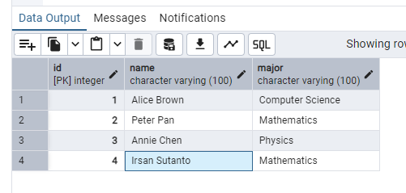

o Five courses:

▪ title: Database Systems, department: computer science

▪ title: Linear algebra, department: mathematics

▪ title: Quantum mechanics, department: physics

▪ title: Python programming, department: computer science

▪ title: Calculus III, department: mathematics

-- Inserting data into the 'courses' table

INSERT INTO course (title, department) VALUES

('Database Systems', 'computer science'),

('Linear algebra', 'mathematics'),

('Quantum mechanics', 'physics'),

('Python programming', 'computer science'),

('Calculus III', 'mathematics');

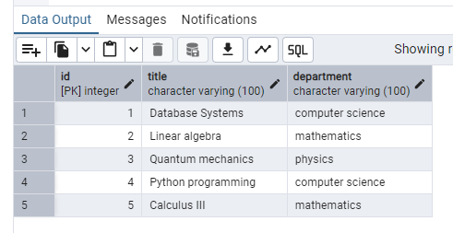

o Enrollments:

▪ Grade of ‘A’, for ‘your name’

▪ Grade of ‘B’ for Annie

▪ Grade of ‘C’ for Peter

▪ Grade of ‘B+’ for Alice

-- Inserting data into the 'enrollments' table

INSERT INTO enrollments (student_id, course_id, grade) VALUES

((SELECT id FROM students WHERE name = 'Irsan Sutanto'), (SELECT id FROM courses WHERE title = 'Database Systems'), 'A'),

((SELECT id FROM students WHERE name = 'Annie Chen'), (SELECT id FROM courses WHERE title = 'Quantum mechanics'), 'B'),

((SELECT id FROM students WHERE name = 'Peter Pan'), (SELECT id FROM courses WHERE title = 'Linear algebra'), 'C'),

((SELECT id FROM students WHERE name = 'Alice Brown'), (SELECT id FROM courses WHERE title = 'Python programming'), 'B+');

• Queries to practice

1. read all students and their major

SELECT name, major

FROM student;

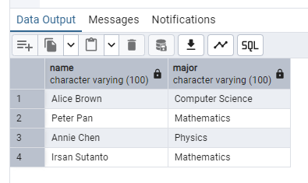

1. read the titles of courses each student is enrolled in.

SELECT s.name AS student_name, c.title AS course_title

FROM students

JOIN enrollments ON s.id = student_id

JOIN courses c ON enrollments.course_id = course.id;

3. read all students with grade and courses.

SELECT s.name AS student_name, e.grade, c.title AS course_title

FROM student

JOIN enrollments ON student.id = enrollment.student_id

JOIN course ON enrollments.course_id = course.id;